Final Project Design Phase
Computer Science - Week 11
Oct 3, 2026 - Version 0.0.4

For complete instructions and project ideas, refer to the assignment in Canvas. Specifically, review the final project requirements before you continue below. If you have not reviewed the project requirements in Canvas (you might have to go to the modules view and check the current or past week's content), you will not be able to properly complete the parts below. In addition, it may be helpful to review the information on this Drafter documentation page.

0) Project Planning and Preparation
Successful programmers spend time planning before they begin coding. After reviewing the project requirements, answer the following questions to help guide your design and development process.
- What concepts from class or previous assignments might help you complete this project? Which programming concepts (loops, conditionals, lists, classes, etc.) do you expect to use? What programming skills do you want to improve while completing this project?
Conditionals, lists, classes, and maybe loops. I want to get better at nesting and making simpler programs

- Which parts of the project do you expect to be the easiest for you? The hardest? Why?
I think writing the math/calculation functions will be the easiest. I think making all the if statements to prevent the user from incorrectly inputting information in will be the hardest

- Even though you have not yet designed the final project, estimate which tasks will likely require the most time and effort? Which features or components should be implemented first?
Doing drafter will probably take the longest, Ill probably do the functions and actual program first

- What distractions might interfere with your work and how will you minimize them? What resources will you need available while working? What questions, if any, do you still have about the assignment requirements?
Loud noises so i will probably go to a quieter room to work.

1) Site Diagram
Create a mock-up of your planned website. We suggest you make the mockup on paper, although you can also use software like PowerPoint or Slides to make a mockup. There is other design software that could also be used, but we strongly encourage you to keep it simple. Do not spend more than 15-30 minutes detailing the mock-up. Your goal should be to make a very quick and dirty diagram, to show that you have some kind of idea.

We recommend drawing each page as a rectangle, and laying out the text, buttons, and other components inside. Then, use arrows to indicate links between pages. Label each page the way you will name each function, and then put labels on the arrows to indicate what the button links. Also write down any parameters that should come into the pages.

In addition to the pages and routes, write down what fields your `State` will have, both their names and types. Think clearly about what data will need to be persistent across the entire website.

Add photo(s) or screenshot(s) of your website mock-up and labeled diagram on the next page.

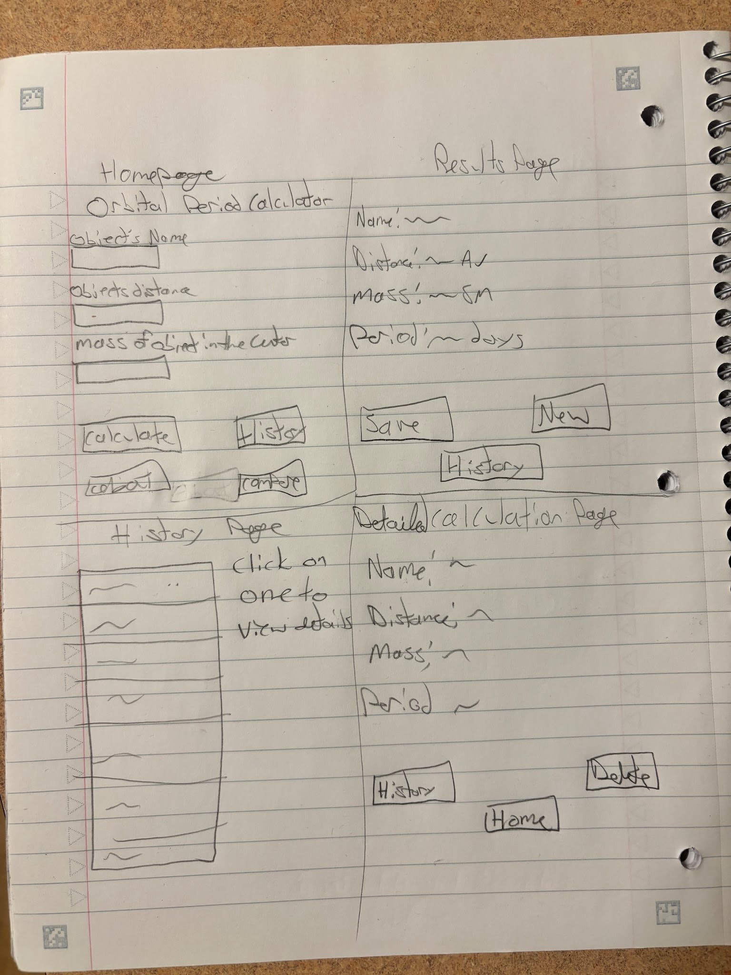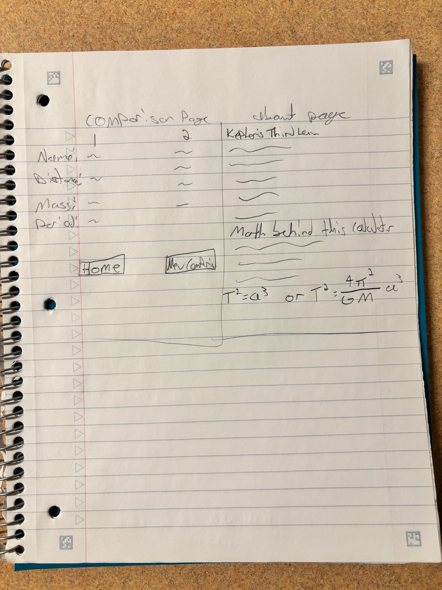
2) Implementing Requirements
This table should serve as a draft for how you will implement the requirements into your final project. You may change your ideas later on, but your final site must fulfill all the requirements.

Requirement | Implementation
Purpose/Functionality  A 1-2 sentence description of the purpose or functionality of your site | Calculate the orbital period of a celestial object
State Dataclass Attributes  Minimum of 4 attributes, one of which must be a list/dict of instances of your second dataclass.  Briefly describe each attribute, its type, and how it will be meaningfully modified throughout the site. | mass_sm = float, mass of the central object in solar masses, will be modified every time user enters a new mass  distance_au = float, distance of object from center in astronomical units, modified every time user enters a new distance  orbital_period = float, calculated orbital period in days, updated whenever the user performs a new calculation  object_name = str, name of object period is being calculated for, updated when user enters name for calculations  calculation_history = list[orbital_calculation], stores a list of previously calculated periods so user can look back at them, whenever calculation is done its information will be added to this list
Second Dataclass  Your second dataclass, including its attributes, their types, and how they will be meaningfully modified (if they are modified) | orbital_calculation  object_name : str, name of object period is being calculated for  mass_sm : float, mass of the central object in solar masses  distance_au : float, distance of object from center in astronomical units  orbital_period : float,calculated orbital period in days
Routes (minimum 7)  The names of your route functions | Index, calculate, save_calculation, history, view_calculation, delete_calculation, compare_calculations, about
Pages (minimum 5)  A brief description of the pages in your site | Homepage, starting page and is where you input data  Results page, displays what the user entered and the calculations, option to go back to homepage and to save the calculation  Calculation history page, displays previous saved calculations  Detailed calculation page, if user selects a previously saved calculation its info will be shown on this page  Comparison page, allows user to select 2 saved calculations to see how distance and mass impact period  About page, information about the calculator and science/math behind keplers third law
User Input (minimum 3)  Description of user input components (TextBox, TextArea, CheckBox, or SelectBox) and their purposes  For more information on these input types, see Drafter Documentation. | TextBox(“mass_sm”) = enters mass in solar masses  TextBox(“distance_au”) = enters distance in au  TextBox(“object_name”) = enters object’s name  SelectBox(“period_unit”) = choses which units to display info (days, years)  CheckBox(“save_calculation”) = allows user to save calculations
If Statements (minimum 3)  Brief description of what will be evaluated in your if statements and how they will meaningfully change the logic of the site | Input validation: makes sure info is inputted correctly (no dividing by zeros or negative numbers)  Calculation simplification: checks if solar mass is 1, if it is will use simplified keplers 3rd law equation if not will use full equation  Save_calculation: check if user saved calculation , if they did will save if not wont
Loop (minimum 1)  This loop must iterate over the list/dict of dataclass instances in your State attribute.  Description of this loop and why it is meaningful to the site | The website will use a for loop to iterate through the calculation_history list in the State dataclass. Each item in the list will be an instance of the OrbitalCalculation dataclass. The loop will access the attributes of each instance, including the object name, central object mass, orbital distance, and orbital period. For each calculation, the website will display its information on the Calculation History page. This allows users to view all of their previously saved calculations without having to perform them again.

LLM Conversation
If you used an LLM in any part of this work, copy and paste every part of that conversation below. Otherwise, you may be given a zero for the assignment. Obviously, these words will not all be yours, and this is the exception to the requirement at the top of this assignment that all responses be in your own words. If you did not use an LLM to assist you in this assignment, simply say so below.
I am making a website that uses inputted orbital distance and central object mass to calculate orbital period, with this website I will have a feature that allows users to save their calculations into a list using dataclasses and users can compare saved calculations. How could I incorportate a loop into this?
A loop would fit very naturally into your orbital calculator! In fact, you have several opportunities to use loops, especially because your application involves saving multiple calculations and comparing them.

I'd recommend incorporating a loop into your saved calculations feature, since it is useful, easy to understand, and directly connected to your application's purpose.

1. Use a loop to display saved calculations
You mentioned using dataclasses to store calculations. You could create a dataclass called Orbit that stores the information for each calculation.

For example, each orbit could contain:

Orbital distance

Central object's mass

Calculated orbital period

A name for the calculation (optional)

You could then store multiple Orbit objects inside a list.

Where the loop comes in:

Whenever the user opens their saved calculations page, use a for loop to go through the list and display every saved orbit.

Example of the logic:

for orbit in saved_orbits:
print(orbit.name)
print(orbit.distance)
print(orbit.mass)
print(orbit.period)

In Drafter, instead of print(), you would build a list of text or other components to display on the webpage.

This is probably the easiest and most practical way to incorporate a loop.

2. Use a loop to compare saved calculations
This is another great opportunity.

Imagine a user has saved three different orbital calculations:

Orbit

Distance

Period

Orbit A

100 million km

50 days

Orbit B

200 million km

140 days

Orbit C

300 million km

260 days

You could use a loop to go through all saved calculations and find the one with the longest orbital period.

For example:

longest_period = saved_orbits[0]

for orbit in saved_orbits:
if orbit.period > longest_period.period:
longest_period = orbit

Your website could then display:

"The orbit with the longest period is Orbit C."

This gives the loop a meaningful purpose beyond simply displaying information.

3. Use a loop to calculate comparisons
You could also use a loop to compare each saved orbit against another orbit selected by the user.

For example, the user selects Orbit A as their reference calculation.

Your program could:

Go through every saved orbit.

Compare its orbital period with Orbit A.

Calculate the difference between their orbital periods.

Display the results.

Example:

for orbit in saved_orbits:
difference = orbit.period - selected_orbit.period
print(difference)

You could display whether each orbit has a longer or shorter period than the selected orbit.

4. How I would organize your project
Here's how I would structure the main features:

Orbital Period Calculator
1. Calculate orbital period

User enters orbital distance and central object mass.

Input and processing
2. Save calculation

Create an Orbit dataclass object and append it to a list.

Dataclasses and lists
3. Display saved calculations

Use a for loop to iterate through the list and display each calculation.

For loop
4. Compare calculations

Use loops and conditional statements to compare orbital periods.

Loops and conditionals
5. My recommendation
For a CS1 final project, I would prioritize these three uses of loops:

Loop

Purpose

Difficulty

Display loop

Display all saved calculations

Easy

Comparison loop

Find the longest orbital period

Easy

Difference loop

Compare periods against a selected orbit

Medium

You don't need to implement all three. Even implementing the first two would give your project a meaningful use of loops.

One important Drafter consideration: Since Drafter runs Python in the browser using Pyodide and doesn't have a traditional backend or database, your saved calculations will need to be stored locally. You could use browser localStorage to preserve them between visits, but initially, I would focus on getting your list of dataclass objects working.

One question to think about: Would you want users to compare two specific saved orbits, or would you rather have the website automatically analyze all saved orbits and identify interesting differences? That decision will help determine how to design your comparison loop.

Final Submission
When you are finished, download this file as a Word Document (docx) and upload the file to the appropriate assignment on Canvas.

